**Contact Person**

Dr Stephen Snow, School of Architecture | The University of Queensland

Email: s.snow@uq.edu.au

|  |  |
| --- | --- |
| University of Queensland  19 September 2022 |  |

|  |
| --- |
| Millaa Millaa Energy Monitoring Insights  Inferring network-side power quality parameters from household-level energy monitoring |

Millaa Millaa Energy Monitoring Insights

Inferring network-side power quality parameters from household-level energy monitoring

|  |  |
| --- | --- |
| GENERAL INFORMATION | |
| Lead Business Name | The University of Queensland |
| ABN (if applicable) | 63 942 912 684 |
| Business type | University |
| Contact person  (authorised to negotiate and enter into a contract) | Dr Stephen Snow |
| Registered business office address | Level 5, Sir Llew Edwards Building (#14)  Cnr University Drive & Campbell Road  The University of Queensland  St Lucia, Qld, 4072 |
| Email | s.snow@uq.edu.au |
| Consortium Business Name/s (if applicable) | N/A |

**Authors:**

Dr Stephen Snow- UQ

Dr Lakshitha Naranpanawe- UQ

Dr Mashhuda Glencross- UQ

Zoran Angelowski- Dius

# List of Acronyms

|  |  |
| --- | --- |
| Acronym | Definition |
| ABS | Australian Bureau of Statistics |
| AEMO | Australian Energy market Operator |
| AER | Australian Energy Regulator |
| ARENA | Australian Renewable Energy Agency |
| DNSP | Distributed Network Service Provider |
| kV / kVA | Kilovolt / Kilovolt-ampere |
| kW /kWh | Kilowatt / Kilowatt hour |
| MV / MVA | Megavolt / Megavolt ampere |
| MW / MWh | Megawatt / Megawatt hour |
| UQ | University of Queensland |
| VPP | Virtual Power Plant |

Contents

List of Acronyms 3

Introduction and context 5

Residential energy monitoring 5

Business energy monitoring 6

Network-side power quality analysis 9

Voltage analysis 9

Power outage analysis 13

Outage analysis- Zone Substation + Feeder 14

Outage analysis- Powersensors 15

Insights and conclusion 17

# Introduction and context

This report details the activities undertaken as part of re-purposing the surplus of ECA Grant: CEO21012: *“Improving post-cyclone energy resilience of regional communities in regional Queensland”.* The grant facilitated the purchase of Powersensors to gather household-level energy use data to better understand energy demand and load signatures of residential dwellings in Millaa Millaa in Far North Queensland. These activities support the larger goal of a Feasbility Study submitted to the ARENA Regional Australia Microgrids Pilot Project, for the development of a microgrid in Millaa Millaa to assist in improving power resilience post-natural disasters.

This report is a collaboration between UQ and Dius and relates to the value-add and contribution to the project provided through the repurposing of funds that were not spent on purchasing energy monitors. **This report should be read in conjunction with the Final Acquittal Report** for this grant which details the change in scope in more detail.

**Original scope:** The orginal scope was to purchase 65 [Powersensor](https://www.powersensor.com.au/) kits (see description below) to monitor the energy consumption of 65 households in Millaa Millaa. In this original scope, the analysis would have been limited to analysing the data available from Powersensor to identify average daily consumption values and compare and segment load profiles (e.g. what time consumption peaks occur).

**Change in scope:** As detailed in the Final Acquittal Report, the number of households motivated and willing to receive a Powersensor was lower than expected, meaning that only half of the budgeted 65 were purchased, leaving a surplus of approximately $6,413 (all dollar values expressed here are approximate only and may differ from those provided in final acquittal). As agreed with Energy Consumers Australia, this surplus was to be retained by UQ and re-purposed on activities related to:

* Additional data analysis,
* Additional report preparation **(this report)**; and
* The preparation of a video showcasing the use of Powersensor energy data in modelling microgrid options in Millaa Millaa.

This change in scope allowed additional data analysis using expertise from UQ and Dius (Powersensor manufacturers) providing valuable insights not only into household level characteristics (e.g. average consumption patterns, load profiles), but additionally, into network-side parameters such as power quality and network outage analysis which would not have been possible without this change in direction.

Overall it is felt that the final outcome (i.e. household level and network level insights) has resulted in greater benefit to the project than if the full 65 Powersensors were installed and only household-level analysis was undertaken.

# Residential energy monitoring

**Powersensors:** Powersensor energy monitors were utilised to gather data from households in the immediate Millaa Millaa town area. Powersensor is one of the first self-install energy monitors on the market and uses magnetic induction to measure power parameters when installed proximal to a residential mainfuse, electricity meter and/or solar inverter cabling (if solar is installed). This option represents a substantial cost saving relative to energy monitors requiring an electrician install and presents far more granular data on consumption and generation than is possible from requesting metering information from the electricity retailer, given smart meters provide 30-minute data and many households in Millaa Millaa still operate rotary dial meters, for which only quarterly information is available. Powersensors once installed transmit energy data to a cloud via a smart plug connected to the users’ WiFi (smart plug and sensor pictured in Figure 1). Multiple data comparisons and visualisations are available through the accompanying app. Users must have WiFi, a meterbox within WiFi range and single phase power (dual and three phase are not supported). More information is available at: [www.powersensor.com.au](http://www.powersensor.com.au).

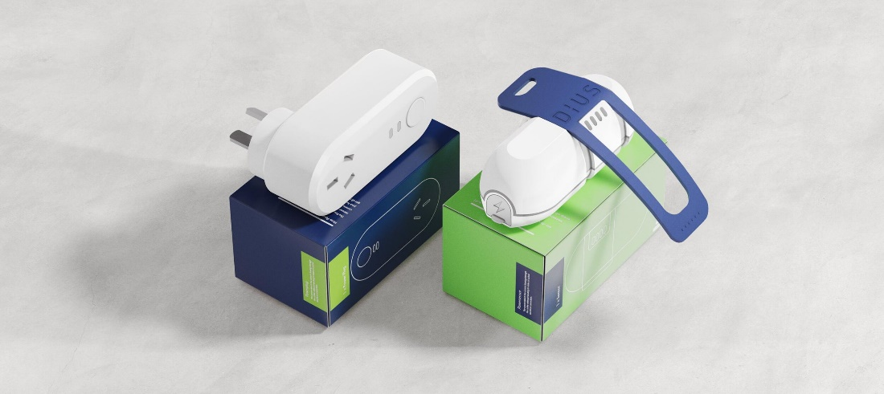

**Figure 1:** Powersensor smart plug and sensor. Source of picture: https://www.design-industry.com.au/dius-powersensor

Powersensors were offered to all householders in Millaa Millaa through the community Facebook grapevine and by Lions Club representatives. 22 households requested a Powersensor, of which 12 were installed. The lower number installed versus requested was related to incompatibility issues with six households (e.g. dual phase power, no WiFi, meterbox outside of WiFi range) and four households taking receipt of the sensors but never installing them despite persuasion and visits from Lions Club representatives, some of which were not confident with technology including smart phones.

The locations of Powersensors relative to the distribution transformers are shown in Figure 2 below and in Table 1, where it can be seen the Powersensors are well distributed across the town, with energy data collected from three houses on each of the three transformers in the town centre and additionally two further properties connected to SS580 to the east of the town (noting that these are best guesses, as Ergon does not provide information on what transformer each house is connected to.

# Business energy monitoring

Additionally, and separately to CEO21012, Phisaver brand energy monitors were installed in five businesses in Millaa Millaa. Businesses can use as much as 10-20 times as much power as households in a single day, hence gathering energy data from businesses in town was an integral part of the larger feasibility study. Consultation with the Millaa Millaa Lions Club determined the likely largest consumers of power in town, namely a restaurant/diner, café, the supermarket (which includes petrol pumping facility), hotel, caravan park and school. Phisaver energy monitors were chosen to monitor these businesses. Phisaver is a multi-CT energy monitor supporting monitoring of up to 14 individual circuits (Figure 2).

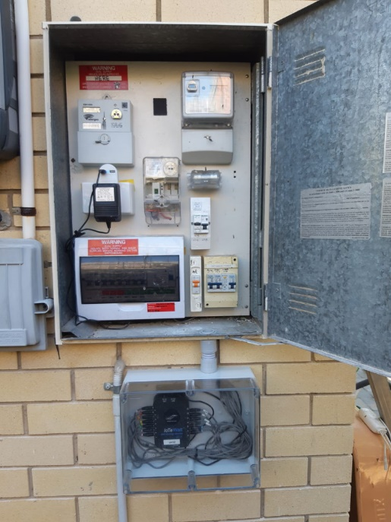

**Figure 2:** Phisaver installed in Perspex enclosure below meterbox. CT’s are clamped behind the meterbox to circuits and main incomers.

The location of the Phisaver energy monitors and the Powersensor energy monitors is available below in Table 1 and Figure 3. This report deals primarily with the repurposing of CEO21012 grant and hence detailed analysis of Phisaver results is beyond the scope of this present report but will be included in the final feasibility study to be submitted to ARENA.

Table 1 below shows the location of the energy monitors relative to the transformers to which (we suspect) the premises is connected. It would require a detailed assessment to determine conclusively which premisis is connected to which network transformer and hence the listings in Table 1 are best guesses. The “Total number” of business and residential customers listed on each transformer is populated with data suppled by Ergon Energy. Note that not all households with Powersensors provided valid data for Voltage and/or Outage.

**Table 1:** Premises with energy monitoring per feeder, relative to total premises on feeder. Refer Figure 3 for location of each of these transformers.

|  |  |  |  |  |
| --- | --- | --- | --- | --- |
| **Feeder** | **Residential customers with energy monitoring** | **Total number of residential customers listed on transformer** | **Business customers with energy monitoring** | **Total number of business customers listed on transformer** |
| SS10112 (Main street) | 3 | 48 | 4 | 14 |
| SS1256 (Oak St) | 3 | 48 | 0 | 3 |
| SS1926 (Maple St) | 3 | 61 | 0 | 11 |
| SS7608 (Caravan Park) | 0 | 4 | 1 | 4 |
| SS580 (Palmerston Hwy) | 1 | 14 | 0 | 0 |
| SS2488 (Palmerston Hwy) | 2 (one out of shot in Figure 3) | 6 | 0 | 2 |

Figure 3 below shows the location of both residential energy monitors (Powersensors) and business energy monitors (Phisavers) alongside the existing network distribution transformers. The residential energy monitors are relatively well distributed

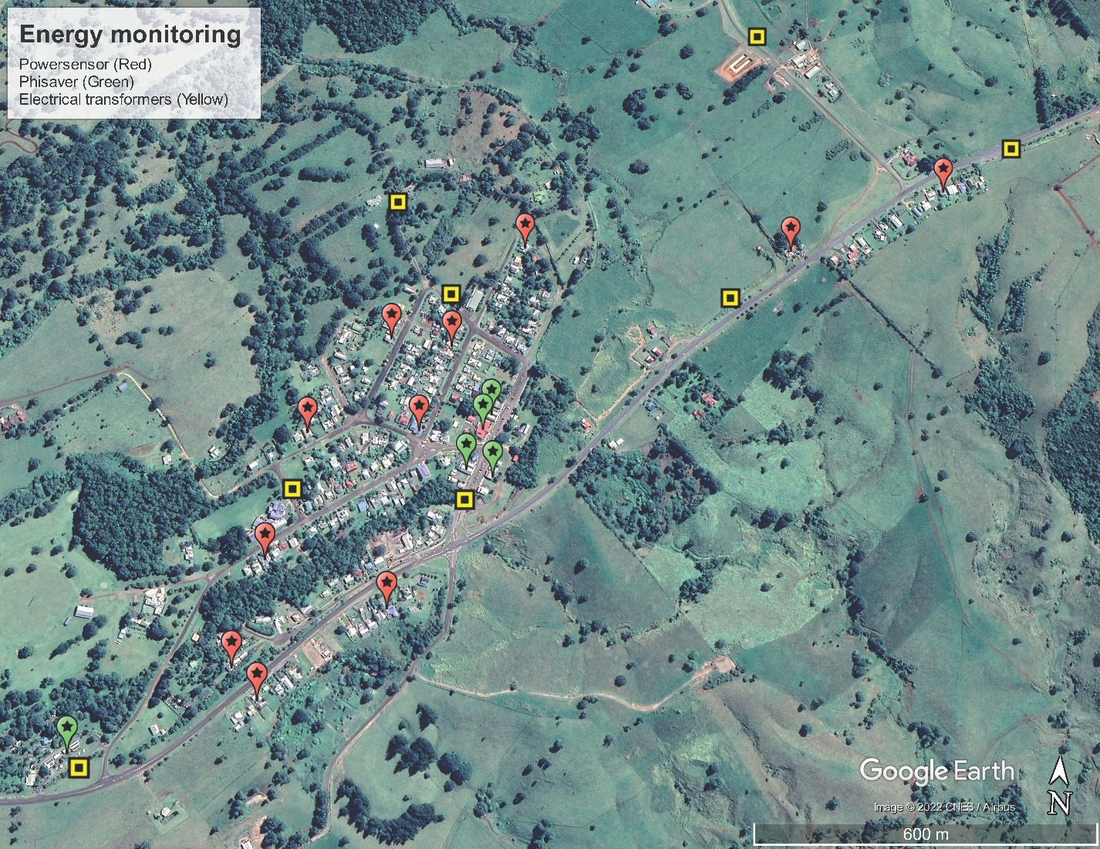

SS1956

SS2488

SS580

SS10112

SS7608

SS1926

**Figure 3:** Location of residential (red) and business energy monitoring (green) relative to the location of network electrical transformers (yellow squares). Note one further premises with a Powersensor installed is out of shot to the top right of the image.

# Network-side power quality analysis

Collaboration with Dius (Powersensor manufacturers) faciliated extraction of data from both the Powersensor plug socket (aggregated energy use data which is transmitted to the Powersensor cloud) as well as high granularity sensor data which required Dius to remote-in to each device and extract raw data from the battery powered sensor itself.

Extracting data from the sensor itself enables determination of the exact timing of power outages and interruptions which is possible but less accuate from the Powersensor plug socket given the socket itself relies on mains power for transmission, whereas the meterbox sensor is battery powered.

Using this additional data extraction and pre-procecssing, two network side parameters were analysed using the household-level Powersensor data: (1) Voltage and (2) Outage analysis.

## Voltage analysis

Australian Standard AS 60038 stipulates the allowable grid voltages to be supplied by DNSP’s in Australia. Voltage is set at 230V +10% -6%, which equates is a range of 216V to 253V[1]. Values within these bounds are acceptable and (sustained) values outside the bounds are counter to DNSP’s electricity delivery obligations.

**Under-voltage:** When measuring voltage at the household level (i.e. behind-the-meter), activities in the house can affect the voltage, meaning that a household-level reading is not always indicative of a network-side reading. Under-voltage events measured behind-the-meter may be indicative of the house drawing a substantial load (e.g. switching on multiple appliances at once), or may be due to network-side undervoltage.

**Over-voltage:** On the other hand, over-voltage events are far more likely to be network-side over-voltage, as household activities can not easily contribute to over-voltage events. For this reason, our analysis concentrates specifically on over-voltage events as indicative of networ over-voltage events and hence poor power quality supplied by the network.

**Voltage analysis process:** Valid voltage measurments were obtained from eight of the houses with Powersensors (Figures 4a-4h below), noting the “house ID” is an anonymised ID used by UQ only. The transformer to which each of these dwellings are connected to are best guesses, as the DNSP does not provide details of which house/business is connected to which transformer.

Based on these voltage plots, it can be stated that some feeders in the Millaa Millaa township are experiencing power quality issues such as overvoltage. Note that not all households with Powersensors provided valid data for Voltage and/or Outage. Only those with valid data are presented here:

**Figure 4a:** Voltage readings May-August 2022 from house ID “0gg” likely to be connected to SS1926 transformer

**Figure 4b:** Voltage readings May-August 2022 from house ID “528” likely to be connected to SS1256 transformer

**Figure 4c:** Voltage readings May-August 2022 from house ID “Bqv” likely to be connected to SS10112 transformer

**Figure 4d:** Voltage readings May-August 2022 from house ID “CeY” likely to be connected to SS1926 transformer

**Figure 4e:** Voltage readings May-August 2022 from house ID “EqL” likely to be connected to SS1256 transformer

**Figure 4f:** Voltage readings May-August 2022 from house ID “r4w” likely to be connected to SS10112 transformer

**Figure 4g:** Voltage readings May-August 2022 from house ID “tuK” likely to be connected to SS2488 transformer

**Figure 4h:** Voltage readings May-August 2022 from house ID “Zly” likely to be connected to SS1256 transformer

Close inspection was carried out on individual over-voltage events on each premesis. Figure 5 presents an example of this inspection, showing a 24 hour period in which over voltage events were recorded. In each case, over-voltage events were short in duration (typically 1-5 minutes). meaning they would not be picked up on feeder level data monitored by the network, given (a) feeder level data covers a far larger area and (b) is comprised of 30 minute averages, meaning short duration (1-5 minute) exceedences would be lost.

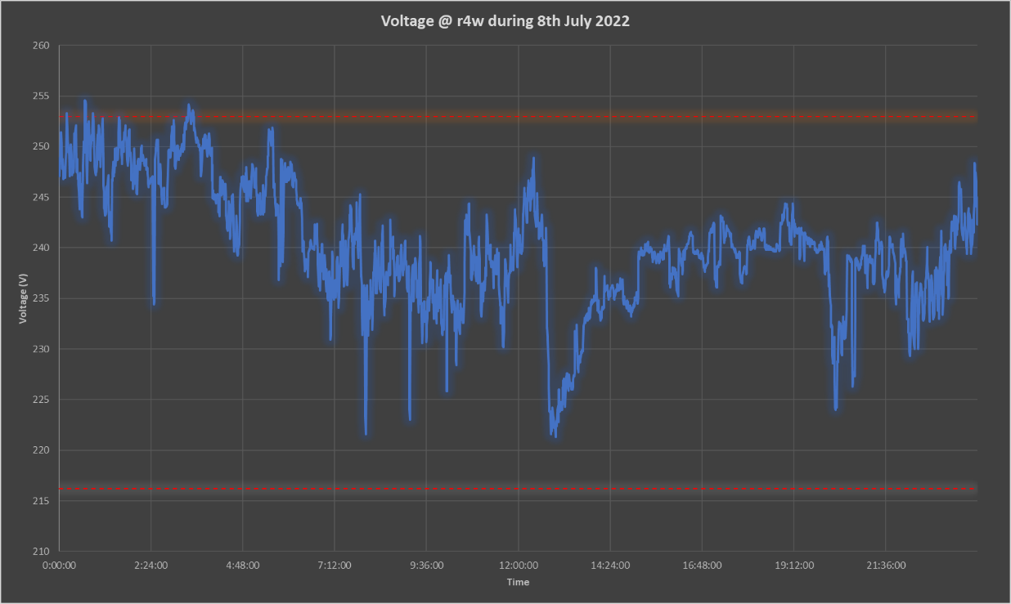

**Figure 5:** Voltage measurements at a dwelling during a 24 hour period where exceedences were recorded. Red lines indivate upper and lower bounds of AS 60038 (216V to 253V)

## Power outage analysis

A second network-side power quality parameter we sought to determine from household level monitoring is power outage data. For this analysis we utilise: (1) publicly available data from the Evelyn Zone Substation, (2) Ergon-supplied data from the Millaa Millaa feeder of the Evelyn Zone Substation, and (3) local behind-the-meter monitoring using Powersensor and Phisaver sensors (described above).

## Outage analysis- Zone Substation + Feeder

**Evelyn Substation data:** 30-minute time series data is publicly available and downloaded from the Ergon Distribution Annual Planning Report Map[2]. The most recent period of downloadable data (at the time of writing) is 01 April 2020 to 28 March 2021 (before Powersensors or Phisavers were installed). The data shows two instances of negative MW loading experienced in May 2021 and February 2021 as well as other less significant fluctuations (Figure 6a, 6b). We speculate the negative loadings may indicate power to the substation or to certain feeders being re-routed, however we cannot confirm the cause.

The red circles in Figures 6a and 6b point to the same event, which is described below.

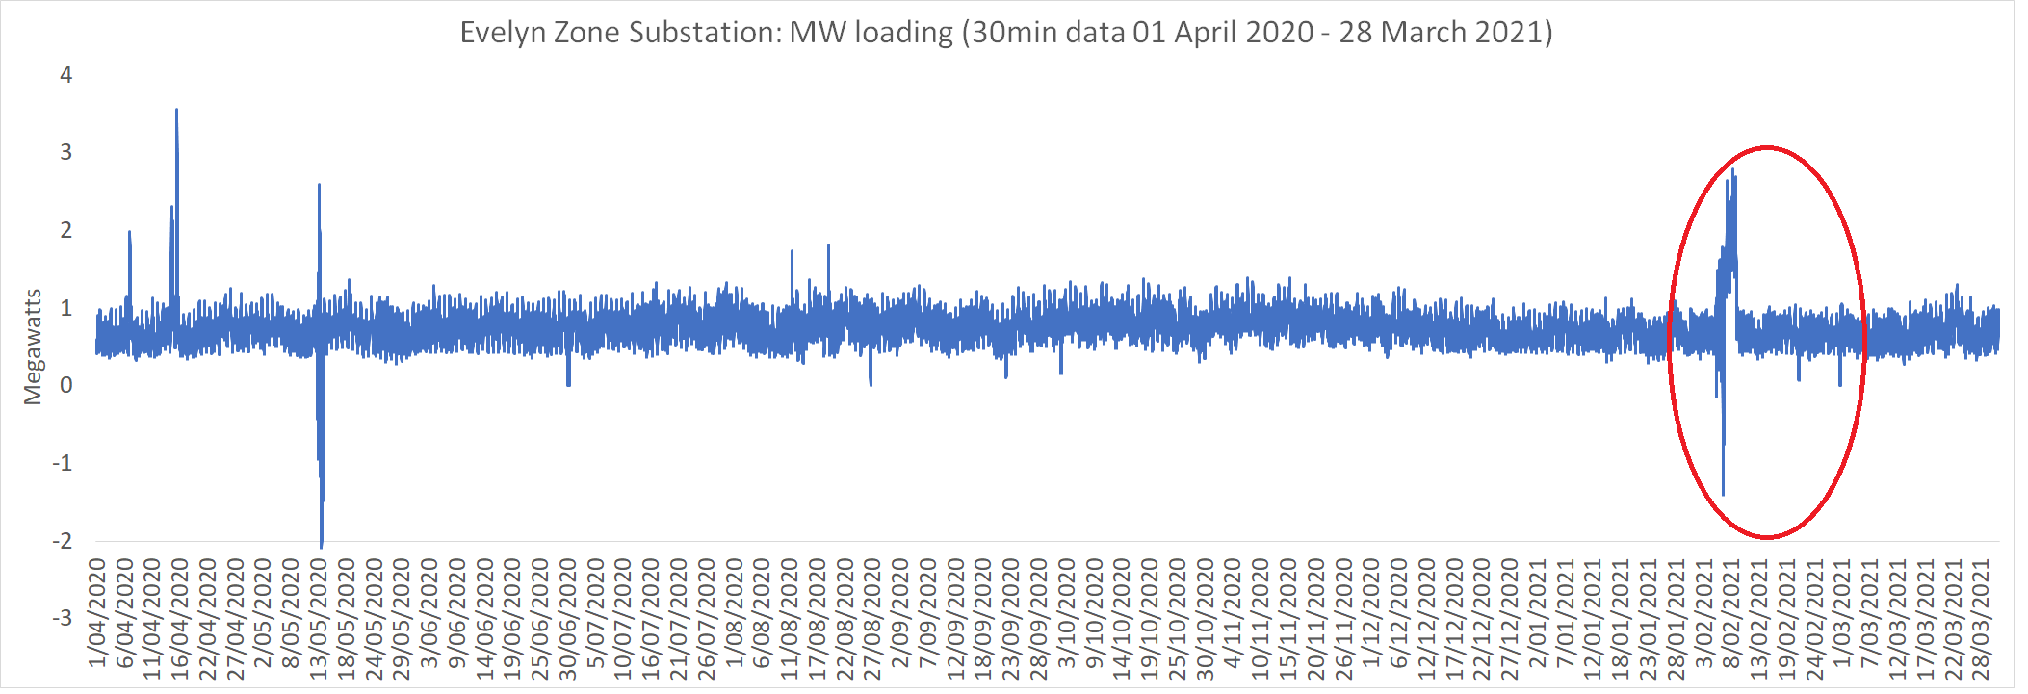

**Figure 6a:** Loading data on Evelyn Zone substation from 1/4/20 to 28/3/21

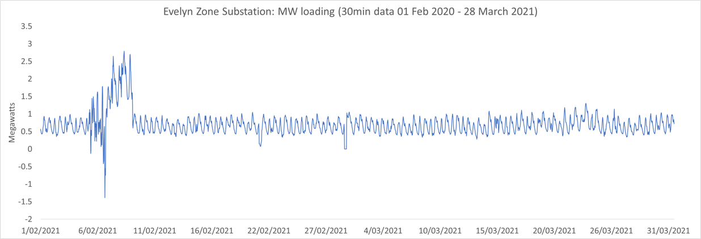

**Figure 6b**: Loading data on Evelyn Zone substation from 1/2/21 to 28/3/21 (this is a zoom in on the red circled portion of Figure 6a).

**Zero-loading MW readings (potential zone substation outages)**

Separate to the negative loading events, there are three separate events of sustained zero-MW readings in the data.

* 30/6/2020 7:30 to 17:00
* 27/8/2020 11:00 to 14:00
* 1/3/2021 7:00 to 11:30

It is important to note that with the 30 minute data frequency of the zone substation data, only outages of 30 minutes or greater would be visible in this data and shorter duration outages or momentary interruptions would not be picked up. **For this reason, the 1-minute data from the Powersensors provides valuable insight into shorter duration outages and power quality parameters, which we discuss below.**

## Outage analysis- Powersensors

Powersensors are capable of recording power outage events with exact time stamps to a 1-minute accuracy. Thus Powersensor outage data can be used to identify possible short duration power outages. Dius conducted an assessment of the detailed events logs from the meterbox sensor, concluding that brown outs appear reasonably common in Millaa Millaa where they observed many logs where the plugs reported periods of low or no voltage for up to 2/3 of a second, followed by the voltage recovering. Often such episodes continue on for many seconds. Dius note this is their our best-effort interpretation of the data we are seeing and that power quality monitoring is not yet a production feature of the consumer device.

Table 2 contains a summary of all > 1 second outages recorded between May (install) and August, recorded across all houses with Powersensor data. The outages are indicative of events where the Powersensor kits experienced a loss of voltage sufficient to result in a reboot. Forty four separate outage events were recorded by Powersensors (Table 2). Most of these records apply only to a single kit, where the cause may be consumer-side or network side, and might be explained by any of the following:

* The customer switched off the power point the plug is inserted into, or pulled the plug out of the power point.
* The customer triggered a circuit breaker or RCD covering the power point the plug is plugged into.
* Localised brown-outs.
* Actual grid supply interruptions.

The records highlighted in blue and orange on the other hand are unambiguous, representing simultaneous outages at three separate properties. They encompass one 72 second power outage on May 10th, and another almost hour-long outage 2.5 hours later on the same day. These power outages were independently observed across three separate kits, with identical start times and durations (within the measurement accuracy). These two examples illustrate that, given a sufficient density of plugs monitoring individual households, it is possible to obtain conclusive evidence regarding grid outages, even if each individual plug is unable to differentiate between the several possible reasons for losing power (Table 2).

**Table 2**: Power outage events recorded by Powersensors including (anonymised) house ID and duration of outage

|  |  |  |  |
| --- | --- | --- | --- |
|  | **Date - Time** | **House ID** | **Duration (sec)** |
| 1 | 2022/4/13 - 18:03 | r4w | 7.47 |
| 2 | 2022/4/16 - 04:50 | r4w | 8.48 |
| 3 | 2022/4/22 - 15:47 | ZIy | 10.44 |
| 4 | 2022/4/28 - 18:33 | ZIy | 4.78 |
| 5 | 2022/4/29 - 01:48 | ZIy | 15.42 |
| 6 | 2022/4/29 - 15:07 | r4w | 389.31 |
| 7 | 2022/4/29 - 20:10 | ZIy | 19.11 |
| 8 | 2022/4/30 - 06:38 | r4w | 5.65 |
| 9 | 2022/5/01 - 12:16 | EqL | 34.41 |
| 10 | 2022/5/10 - 16:24 | r4w | 72.02 |
| 11 | 2022/5/10 - 16:24 | EqL | 71.98 |
| 12 | 2022/5/10 - 16:24 | ZIy | 72.90 |
| 13 | 2022/5/10 - 18:59 | r4w | 3416.73 |
| 14 | 2022/5/10 - 18:59 | EqL | 3416.65 |
| 15 | 2022/5/10 - 18:59 | ZIy | 3416.72 |
| 16 | 2022/5/16 - 10:01 | EqL | 15.37 |
| 17 | 2022/5/19 - 08:58 | ZIy | 181.46 |
| 18 | 2022/5/19 - 09:08 | ZIy | 5972.45 |
| 19 | 2022/5/21 - 13:33 | CeY | 16.74 |
| 20 | 2022/5/22 - 17:03 | 0gg | 6.56 |
| 21 | 2022/5/23 - 16:15 | ZIy | 732.05 |
| 22 | 2022/5/24 - 06:32: | CeY | 7.87 |
| 23 | 2022/5/24 - 16:47 | Bqv | 9.13 |
| 24 | 2022/5/25 - 16:33 | Bqv | 1280888.20 |
| 25 | 2022/6/06 - 07:34 | 528 | 10.04 |
| 26 | 2022/6/06 - 20:32 | tuK | 22.81 |
| 27 | 2022/6/07 - 16:16 | tuK | 17.22 |
| 28 | 2022/6/16 - 11:00 | 528 | 8.48 |
| 29 | 2022/6/16 - 16:15 | CeY | 6328.18 |
| 30 | 2022/6/20 - 03:13 | ZIy | 6.19 |
| 31 | 2022/6/20 - 15:34 | Bqv | 4.22 |
| 32 | 2022/6/23 - 07:19 | CeY | 9.88 |
| 33 | 2022/6/23 - 18:06 | CeY | 181.06 |
| 34 | 2022/7/02 - 22:59 | 0gg | 10.47 |
| 35 | 2022/7/13 - 12:13 | EqL | 4.67 |
| 36 | 2022/7/27 - 12:17 | CeY | 3.40 |
| 37 | 2022/7/28 - 09:21 | 0gg | 4634.99 |
| 38 | 2022/7/28 - 10:38 | 0gg | 12.31 |
| 39 | 2022/7/28 - 10:39 | 0gg | 2.21 |
| 40 | 2022/8/01 - 09:47 | CeY | 11.96 |
| 41 | 2022/8/01 - 09:48 | CeY | 5.62 |
| 42 | 2022/8/01 - 12:52 | CeY | 2079.47 |
| 43 | 2022/8/02 - 14:58 | CeY | 733.88 |
| 44 | 2022/8/03 - 21:58 | 0gg | 5.84 |



**Figure 7:** Location of SS10112 and SS1256 transformers (denoted by red circles around the yellow transformers). This figure is an adaptation of Figure 3 above

It is not possible to determine which transformer which houses are connected to, but based on a best guess, we expect that the houses involved in the simultaneous outage events (Table 2) were connected to SS10112 and SS1256 distribution transformers, suggestive that both these transformers lost power, while the lack of simultaneous outage reports from all other Powersensors suggests that the outages were localised to these two transformers only.

As per the voltage fluctuations described in the previous section, these short outages (e.g. > 30 minute) and outages which affect a small number of transformers (rather than all the transformers on the whole feeder) would simply not be picked up by the 30-minute feeder level or Zone Substation level data monitored by the DNSP.

# Insights and conclusion

This report demonstrates the substantial extent of inference possible into network side power quality parameters including voltage and outages, using consumer-level energy monitoring. By corroborating data from multiple households it is possible to separate individual household outages (which may be caused by the household themselves) and network-side outages in which multiple Powersensors record zero-values simultaneously.

Short duration outages or over-voltage events and outage events that affect only a small number of transformers are not likely to be picked up by network level monitoring by DNSP’s.

Ergon Energy maintains a list of “Worst Performing DistributionFeeders”[3] which helps guide investment in the network. The Millaa Millaa feeder has not been on the worst performing feeder list in the recent past, however this report shows that there may be significant power quality issues experienced by customers which DNSP’s would not be aware of.

Our broader research agenda for this project is on the delivery of a feasibility study for a microgrid at Millaa Millaa. Part of this feasibility study is providing an economic, social and network-side case for the need for a microgrid to improve energy resilience. The results that this repurposing of CEO21012 funds has delivered, show the substantial value add possible through detailed analysis of relatively inexpensive consumer energy monitoring software.

This analysis would not be possible without our project partners **Dius** who conducted substantial data extraction, data cleaning and data analysis to support this report. We expect this process is generalisable, in that with a greater nmber of Powersensors across a larger geographic area it would be possible to determine other localised outages, as well as corroborate whole-of-feeder outages with network data and we hope to be able to use the same methodology elsewhere to transcend the insights possible using less granular network-side data only.

1. https://www.australianrectifiers.com.au/regulatory/ac-supply-voltage-ratings-in-australia-have-been-lowered/
2. https://www.ergon.com.au/network/network-management/future-investment/distribution-annual-planning-report/dapr-map-2020
3. https://www.ergon.com.au/network/network-management/future-investment/distribution-annual-planning-report